Fall, 2021
October Meeting in Pendleton County
On Saturday, October 16, 2021, the meeting of the Alpha Kappa Chapter of Delta Kappa Gamma Society International was held at Seneca Rocks Presbyterian Church in Seneca Rocks, WV. The tables were beautifully adorned with brightly colored leaf table runners and autumn table decorations. Favors included homemade Butterfinger and Pay Day bars.
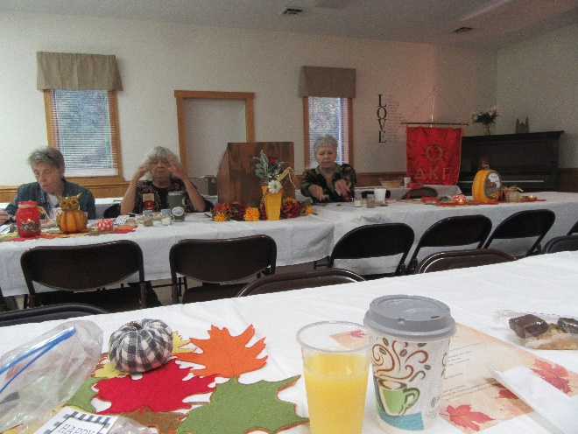
President Vickie Skavenski welcomed everyone. Sue Harper gave the blessing before members enjoyed a delicious breakfast including Lucy Kisamore’s famous cinnamon rolls catered by the Ladies of High Rock United Methodist Church. Carolyn Harper led everyone in reciting the Pledge of Allegiance. Sue Harper and Sharon Harr presented devotions entitled “Ten Lessons Trees Can Teach Us”. We are reminded to take time, be patient, work together, adapt, rest, trust, and never forget our freedom, uniqueness, and foundation as we live each day.
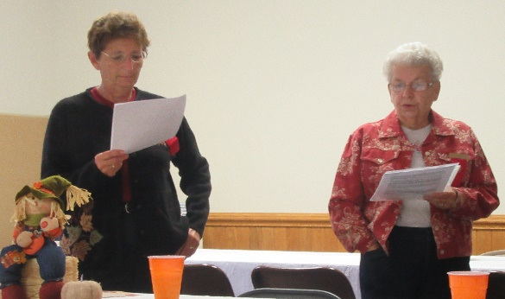

Volume 16 Number 2
President Skavenski shared information from WV State: Nominations for the Local Leading Lady are due by November 1st. All recognized Local Leading Ladies will receive a pin that was designed by our own, Vickie Saville.
A list of questions for Honors for new history was sent via e-mail to all members. Responses to those should be sent back to Vickie Skavenski.
The Founders’ Day skit “Hats Off” to DKG will be presented at the WV State Leadership conference in Flatwoods on April 30, 2022. Volunteers from our group will need to attend to present it.
In 2011-12 DKG membership was 1,304 members in 34 chapters by 2019-2020 membership dropped to 841 members in 24 chapters. Members are encouraged to bring the name of at least one potential member to the November meeting. Invitations will be sent to those named. Applications received will be reviewed and voted on in March with an induction ceremony held in April.

November Meeting in Hardy County
On Saturday, November 6, 2021, the meeting of the Alpha Kappa Chapter of Delta Kappa Gamma Society International was held at Moorefield Middle School in Moorefield, WV.
Thirteen members were present including two on Zoom. The tables were beautifully decorated with patriotic decorations of red, white, and blue. Each member was given a miniature flag and flag key chain. Hand created placemats and red, white, and blue Oreo cookies adorned the tables. The members enjoyed a delicious breakfast catered by Betty Coffman.
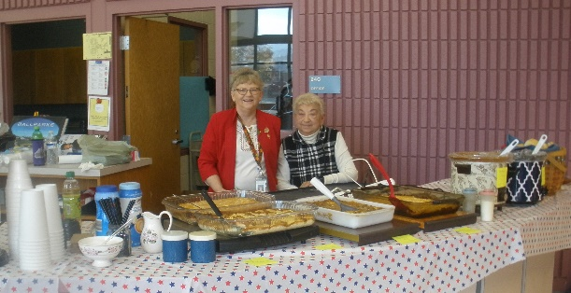
The blessing was given by Amber Champ who also led devotions about Freedom citing Psalm 138. She reminded us to be thankful for the gift of freedom.
Local Leading Lady applications were submitted for Vickie Skavenski, Ann Bennett, Gayle Allen, JoAnn Harman, and Donna Bodkins.
A discussion was held concerning centralized locations for meetings including the Forman Community Building and Moorefield Middle School. Cynthia Yokum made a motion to hold two meetings at the Forman Community Building and two meetings at Moorefield Middle School. The next meeting will be at the Forman Community Building in March with
Grant County hosting.
President Skavenski appointed Beverly Mathias to be treasurer since the treasurer needs to be present at meetings, submit information to the state in a timely manner, and be available to reimburse and deposit money after meetings. We are extremely thankful to Marianna Leone for her dedication to Delta Kappa Gamma and many years of service. We extend prayers to Marianna and hope to see her at the spring meetings.
Vickie Skavenski and Susan Garrett presented an informational program on How to Create a Barn Quilt. Vickie shared many examples of Barn Quilts and explained the steps of making a quilt. Susan told how Donna Sue Groves started the barn quilt movement and the locations of different barn quilts in WV. Hardy County even has a barn quilt organization.
Raffle winners were Vickie Skavenski (Pendleton County), Cynthia Yokum (Pendleton County), Carolyn Harper (Pendleton County) Sue Harper (Pendleton County), and Susan Garrett (Hardy County).

Plans are to hold the March 19th meeting at the Forman Community Center.
The auction raised $750 for the Armanda Heavner family.

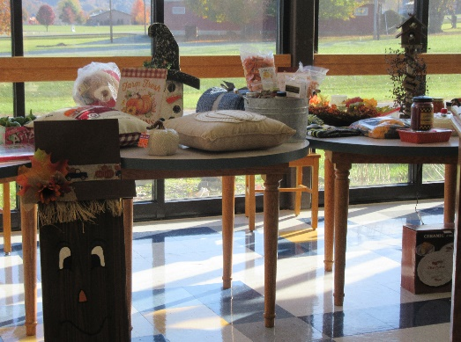

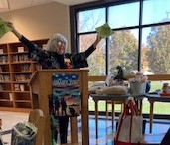

Gayle Allen is pleased to announce her son’s marriage last June. Jonathan and Morgan now reside in Norristown, PA. Her daughter graduated from the University of Tennessee with a master’s degree in architecture and is now employed with an architecture firm in Falls Church, VA. Her other son is now a proud homeowner in Garden City, Idaho. Gayle plans to retire in June 2022 with 40 years of teaching in WV public schools.
Betty Inskeep was honored to receive the First Place Award for the Short Story Competition at the annual Conference of the WV Community Educational Outreach Service (CEOS), a part of WVU Extension. Her touching story was entitled “The Significance of of Peaches” where she related poignant memories of her family associated with peaches. Ask her to read her story!
Gayle Allen was listed as a Recycling Superhero in a publication titled “WV Recycles” for her efforts in helping her school, Springfield-Green Spring Elementary School, recycle plastic.
Bev Mathias and Pam Boggs will be going to Lancaster in November to Sight and Sound Theater to see “Esther” and do a little shopping/sightseeing.
Donna Bodkins and her 80-year-old mother, Betty Coffman flew to South Dakota this past summer and enjoyed Mt. Rushmore, the Badlands, and tours of beautiful rock formations. They traveled on October 30th to see Esther and will be going on November 17th to Hilton Head, S.C. for the VFW meeting and to enjoy Thanksgiving in Bradeton, FL. While in Florida they plan to relax and visit the grave of Donna’s deceased husband.
Amber Champ enjoys being a member and meeting with other DKG ladies. She is proud of the organization and all the good work we are doing.
Donna Bodkins enjoys all the projects President Skavenski brings to our chapter.
Ann Bennett’s family was recognized in The Pendleton Times for being a Recycling Champion by the Recycling Coalition of West Virginia. They are also active in collaborating with the North Fork 4-H club to host recycling events.

Ruth Ann Columbia is critically ill and needs our prayers.
Jane Kessel is home recovering from a shoulder replacement.
JoAnn Harman’s husband needs continued prayers as he recovers at home. JoAnn is unable to attend meetings while the risk of the Covid-19 is high.
Amber Champ lost her grandmother on October 11th as the result of an automobile accident. Prayers are appreciated.
Becky Heavner’s mother-in-law, Armanda Bible Heavner is currently in an assisted leaving facility battling Alzheimers. She is doing well at the facility. Armanda is a former member.

The R.O.S.E. award in October was presented to Sue Harper for always being a “Voice in the Wilderness” as she responds to emails quickly and is always willing to lend a helping hand.

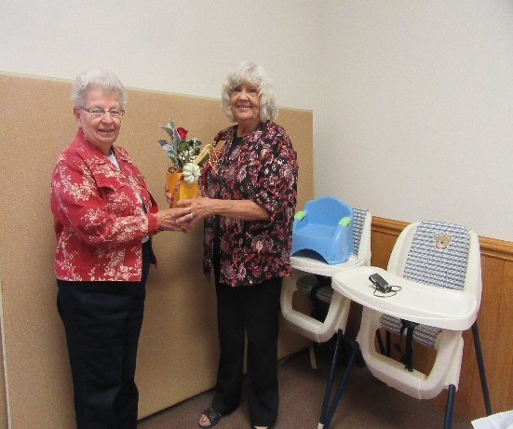

The R.O.S.E. award in November went to Donna Bodkins for hosting such a lovely meeting and welcoming everyone with “Mi Casa es Su Casa”

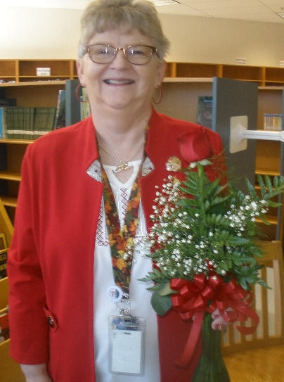

Bits of Information from Our President

I hope you have a wonderful Thanksgiving and I wish you a Merry Christmas with family and friends. The last two Alpha Kappa meetings we had were like reunions with family—we loved the ones who were there but missed those who could not make it. We tried Zoom and Vickie Saville was able to join us—JoAnn Harman came through on FaceTime. I will do better with the invitations next time, I promise.
We have found ourselves facing several issues which we are trying to deal with in the best possible ways. First, we have counties who are finding it difficult to host meetings because of a limited number of active members. To remedy this, we are suggesting two central meeting places—the Forman Center in Grant County (March 19, 2022) and Moorefield Middle School in Hardy County (April 16, 2022). Hampshire County will be the host club for the March meeting and Mineral County will be responsible for the April meeting. Please do not be anxious about this—I will work through the details with you. I believe the Lahmansville CEOS club will do the brunch in Grant County. At this meeting we will present a list of new members for us to vote on—induction will be at the April meeting. If you have an idea for a program, please let me know—otherwise, I will contact the Programs for Educational Excellence Chair, Beverly Mathias, and we will find a program. Then, your only responsibility would be the blessing, meditations, and maybe some table décor or favors. The program for the April meeting will be the induction of new members—please send me names of teachers and where they work that could be invited to become active members of Delta Kappa Gamma. At this point I have about six names, I would love to have ten per county. We need new members desperately and I know that there is competition for the Saturdays of younger teachers, but we must keep offering Alpha Kappa and DKG as a great resource for them. Whatever either county needs to host, just call me and we will work it out—or I will call you if I do not hear from you—we can do this! Once we have the names, Carolyn Harper, Membership Chair, and I will send out the letters requesting their information if they are interested in joining
Secondly, there is a need for our treasurer to be present at every meeting. Marianna Leone has been valiantly trying to keep going with all her health problems, but the time has come to let her rest and retire from this strenuous job. Beverly Mathias has been appointed as the new Alpha Kappa treasurer and we will be meeting with Marianna soon to make the transfer. Thank you, Marianna, for everything that you have done for our chapter.
Third, we have not had updated books—this really slipped because we were not doing anything at the beginning of the Covid pandemic. I have the updated information for the books, will take it to the printer, and as soon as it is ready—after Thanksgiving, Carolyn and I will do the loop again (like we did with the Sunshine Bags) and deliver to a county coordinator for distribution.
Fourth, we have a bag I purchased as our chapter door prize for the state conference. Some members expressed an interest in purchasing one. If you want, please send me an e-mail to order you one and I will do a group order—the bags are $14 and look like this--
.

